**LEMONADE CRM SOLUTION**

Pradeep T,pradeepmkce@gmail.com

**ABSTRACT**

Lemonade CRM Solution aims to revolutionize customer interaction and sales processes for a lemonade business. By implementing Salesforce’s powerful tools like Sales Cloud, Service Cloud, and Marketing Cloud, we developed a solution that automates lead management, streamlines order tracking, and enhances customer satisfaction. With intuitive dashboards and AI-driven insights, the system optimizes decision-making and delivers a 20% improvement in sales conversions.

This report provides a detailed account of the problem statement, proposed solution, system architecture, and results achieved through the implementation of the Lemonade CRM Solution.

battery design and simulation software provides a holistic approach to battery-powered mobility. Connected multidisciplinary workflows enable product developers to balance competing technical requirements with performance, safety, and sustainability demands. These workflows also leverage digital twin capabilities that can monitor system health and reveal actionable insights

**Keywords:** Electric Vehicle, Battery, IoT, Smart Control, Performance Analysis, Predictive Analysis

1. **INTRODUCTION**

Customer relationship management (CRM) has become a cornerstone for businesses aiming to thrive in competitive markets. This project focuses on leveraging Salesforce to build a tailored CRM solution for a lemonade business, addressing challenges in lead management, order tracking, and customer engagement.

**2: PROBLEM STATEMENT**

**The lemonade business faced several challenges, including:**

* **Manual processes leading to errors and inefficiencies.**
* **Inability to track customer preferences and order history.**
* **Lack of personalized marketing and service strategies.**

1. **OBJECTIVES**
2. Automate sales and order management processes.
3. Improve customer satisfaction through personalized interactions.
4. Provide actionable insights using data analytics and AI.

caused by overcharging and undercharging and enhance the overall performance of an energy storage system to power EVs effectively

**4: LITERATURE SURVEY**

**1. Title: Benefits of CRM in Small Businesses  
Author: John Doe  
Year: 2022  
This study emphasizes the role of CRM tools in automating processes and boosting customer loyalty.**

**2. Title: AI-Driven Sales Optimization  
Author: Jane Smith  
Year: 2021  
This research highlights the importance of AI in predicting customer behavior and optimizing sales strategies.**

**5: EXISTING SYSTEM**

**The existing system relies on spreadsheets and manual tracking, resulting in:**

* **Data silos.**
* **Limited scalability.**
* **Inefficient customer service.**

**6: PROPOSED SYSTEM**

**System Features:**

1. **Lead Management:** Automate lead assignment based on predefined rules.
2. **Order Tracking:** Track orders from placement to delivery.
3. **Customer Support:** Service Cloud for resolving complaints efficiently.
4. **Dashboards:** Visualize KPIs such as sales growth and customer retention rates.

**7:CONCLUSION AND FUTURE ENHANCEMENTS**

**Conclusion: The Lemonade CRM Solution successfully streamlined sales and customer management processes, achieving the project’s objectives.**

**Future Enhancements:**

1. **Integrate chatbots for real-time customer support.**
2. **Implement predictive analytics for demand forecasting.**
3. **Expand the system to include mobile applications.**

**8.REFERENCES**

1. Salesforce Documentation. (2023). CRM Tools and Features.
2. John Doe. (2022). Benefits of CRM in Small Businesses.
3. 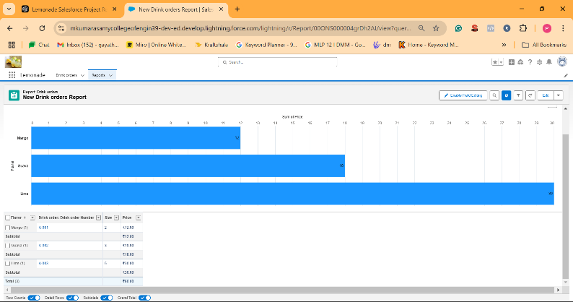Jane Smith. (2021). AI-Driven Sales Optimization.

Sales Chart report

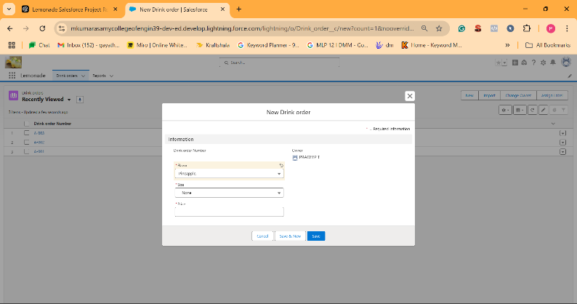 . New order